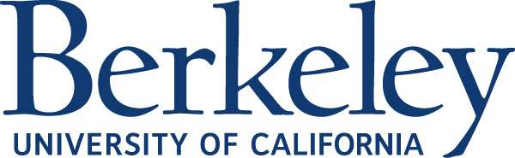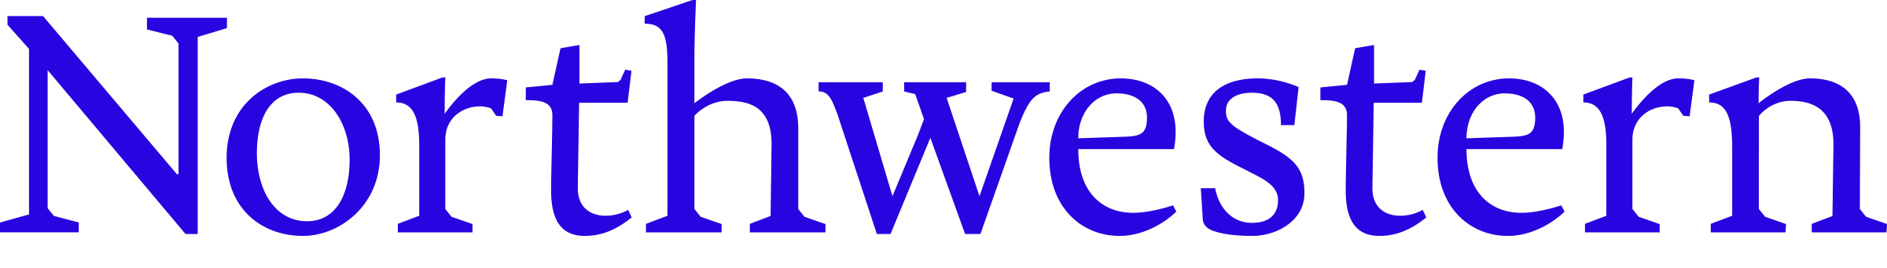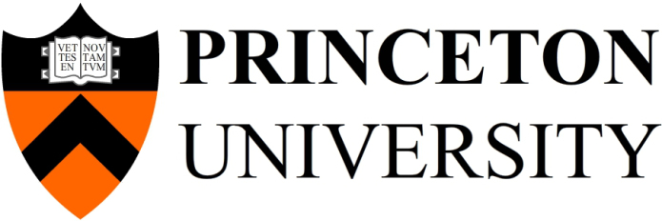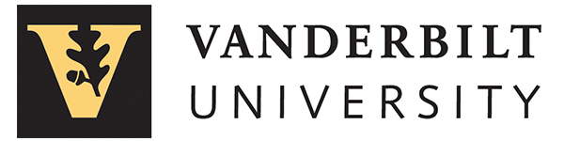

Please join admissions representatives from

**Northwestern University**

**Princeton University**

**University of California at Berkeley**

**Vanderbilt University**

Sunday, Oct. 23, 2016

7:00 – 8:30pm

Anchorage Museum

625 C St.

Anchorage, AK 99501

Monday, Oct. 24, 2016

7:00 – 8:30pm

Raven Landing Center

1222 Cowles St.

Fairbanks, AK 99701

The program will include an introduction to each institution, followed by panel discussion and tips for the admission and financial aid process. Parents are welcome to attend.

[ugadmission.northwestern.edu/  
register/anchorage2016](file:///C:\Users\skw457\AppData\Local\Microsoft\Windows\Temporary%20Internet%20Files\Content.Outlook\EV0W0I4Z\ugadmission.northwestern.edu\register\anchorage2016)

[ugadmission.northwestern.edu/  
register/fairbanks2016](file:///C:\Users\skw457\AppData\Local\Microsoft\Windows\Temporary%20Internet%20Files\Content.Outlook\EV0W0I4Z\ugadmission.northwestern.edu\register\fairbanks2016)